Design Patterns in Java
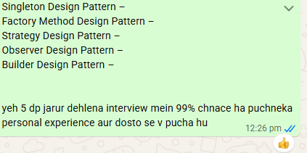

Introduction
Design Patterns are nothing but, we can say, documented and tested solutions for recurring problems in a given context. So, in simple words, we can say that Design Patterns are reusable solutions to the problems that, as a developer, we encounter in our day-to-day programming. It helps to reusability, maintainability & flexibility of our code. Design Patterns are basically used to solve the problems of Object Generation and Integration.

There are three categories of design pattern:
- Creational Design Patterns: In simple words, we can say that the Creational Design Pattern deals with Object Creation and Initialization. These provide a way to easily create objects while hiding the creation logic. This gives the program more flexibility in deciding which objects need to be created for a given use case.
- Structural Design Patterns: These work with class and object composition and use inheritance to write interfaces and obtain new functionality.
- Behavioral Design Patterns: These are concerned with communication between objects.

1. Creational Design Pattern:

When to use the Creational Design Pattern in Real-Time Applications?
In a project there are tons of classes that means we need to create tons of objects. If the client code wants to create the object based on some condition. Client code means the class that is going to consume the objects by calling the methods and properties of such objects.
The Creational Design Pattern helps us to centralize the object creation and initialization logic and depending upon the condition, it will create, initialize, and returns the appropriate object to the client, and then the client then can consume the object by calling the necessary methods and properties

1.1 Singleton Design Pattern:
If want to create a single instance of a class throughout the application. This pattern also helps to provide global access to that instance.
We can achieve this by providing a global access point to that instance and by restricting the creation of new instances.

The pattern typically involves the following components:
- Private Constructor: The class has a private constructor to prevent direct instantiation of the class from other classes.
- Private Static Instance: Private static variable of the same class that is the only instance of the class.
- Public Static Method: Public static method that returns the instance of the class, this is the global access point for the outer world to get the instance of the singleton class.

Different approaches to singleton pattern implementation:
1. Eager initialization:
In this approach, the instance of the singleton class is created at the time of class loading. The drawback to eager initialization is that the method is created even though the client application might not be using it.
Here is the implementation of the static initialization singleton class:
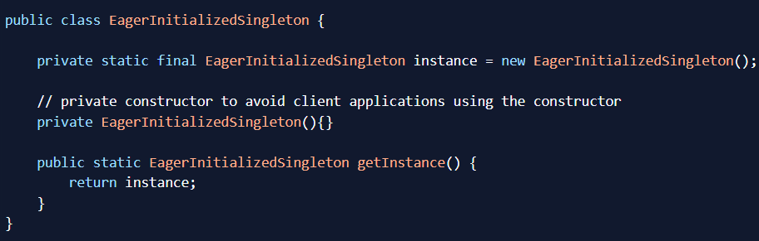
2. Static block initialization:
Static block initialization implementation is similar to eager initialization, except that instance of the class is created in the static block that provides the option for exception handling.
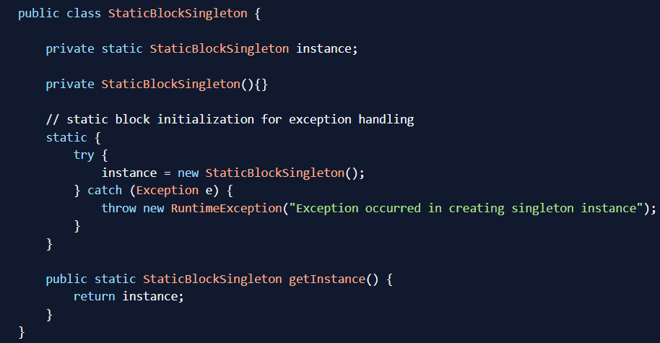

3. Lazy Initialization:
Lazy initialization method to implement the singleton pattern creates the instance in the global access method. 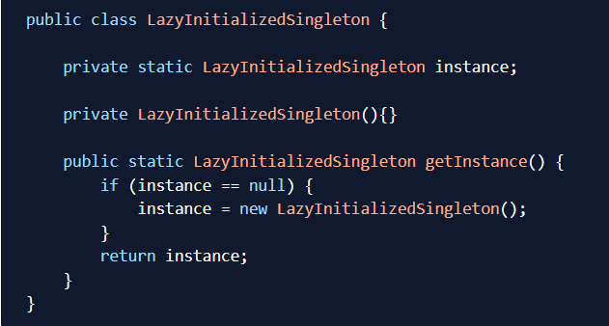
This implementation works fine in the case of the single-threaded environment, but when it comes to multi-threaded systems, it can cause issues if multiple threads are inside the if condition at the same time. It will destroy the singleton pattern and both threads will get different instances of the singleton class. In the next section, we will see different ways to create a thread-safe singleton class.
4. Thread Safe Singleton:
A simple way to create a thread-safe singleton class is to make the global access method synchronized so that only one thread can execute this method at a time. Here is a general implementation of this approach:
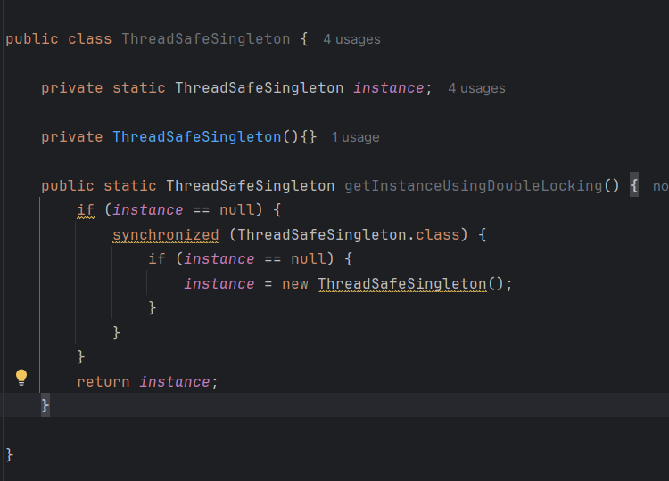
5. Bill Pugh Singleton Implementation:
Prior to Java 5, the Java memory model had a lot of issues, and the previous approaches used to fail in certain scenarios where too many threads tried to get the instance of the singleton class simultaneously. So Bill Pugh came up with a different approach to create the singleton class using an inner static helper class. Here is an example of the Bill Pugh Singleton implementation:
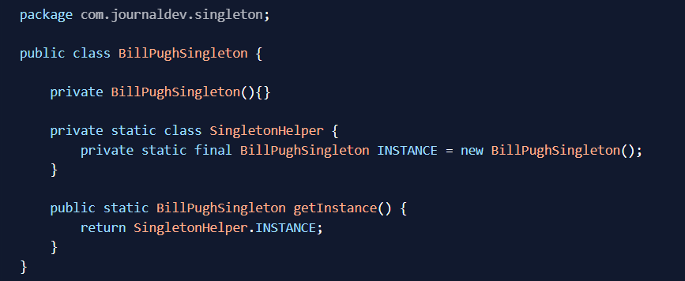
Notice the private inner static class that contains the instance of the singleton class. When the singleton class is loaded, SingletonHelper class is not loaded into memory and only when someone calls the getInstance() method, this class gets loaded and creates the singleton class instance. This is the most widely used approach for the singleton class as it doesn’t require synchronization.
6. Using Reflection to destroy Singleton Pattern:
Reflection can be used to destroy all the previous singleton implementation approaches.
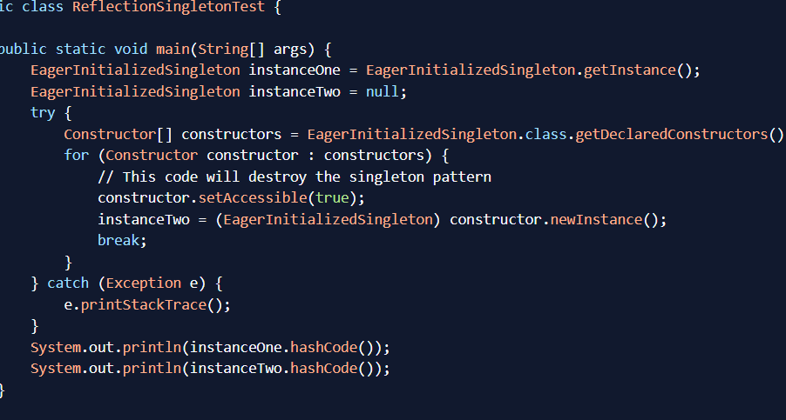
When you run the preceding test class, you will notice that hashCode of both instances is not the same which destroys the singleton pattern. Reflection is very powerful and used in a lot of frameworks like Spring and Hibernate. Continue your learning with Java Reflection Tutorial.
1.2 Factory Design Pattern:
The factory design pattern is used when we have a superclass with multiple sub-classes and based on input, we need to return one of the sub-class. This pattern takes out the responsibility of the instantiation of a class from the client program to the factory class.

Factory Design Pattern Super Class:
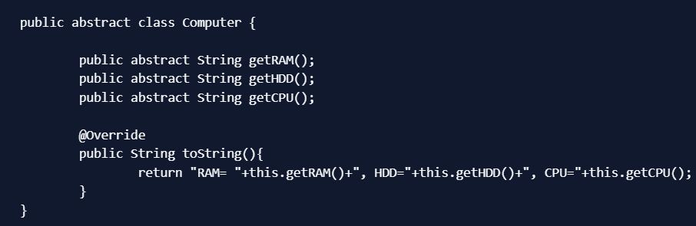
Factory Design Pattern Sub Classes:
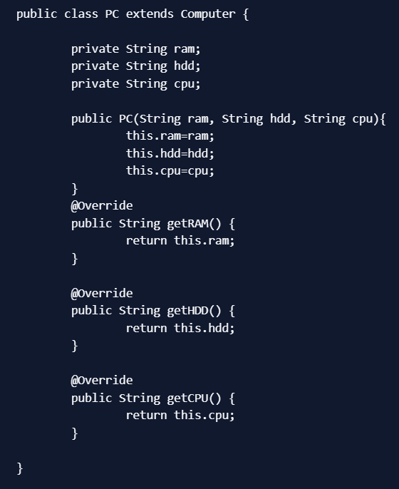
Notice that both the classes are extending Computer super class.
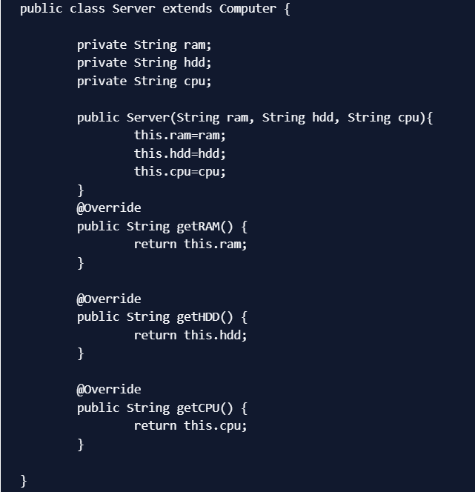
FACTORY CLASS:
Now that we have super classes and sub-classes ready, we can write our factory class. Here is the basic implementation.
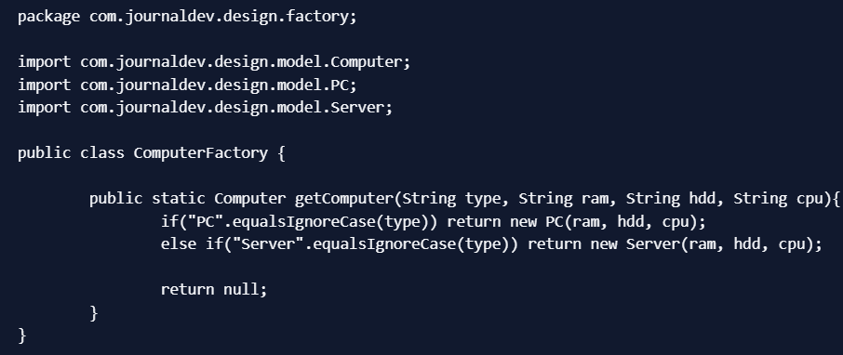
Some important points about Factory Design Pattern method are;
We can keep Factory class Singleton or we can keep the method that returns the subclass as static.
Notice that based on the input parameter, different subclass is created and returned. getComputer is the factory method.
Here is a simple test client program that uses above factory design pattern implementation.
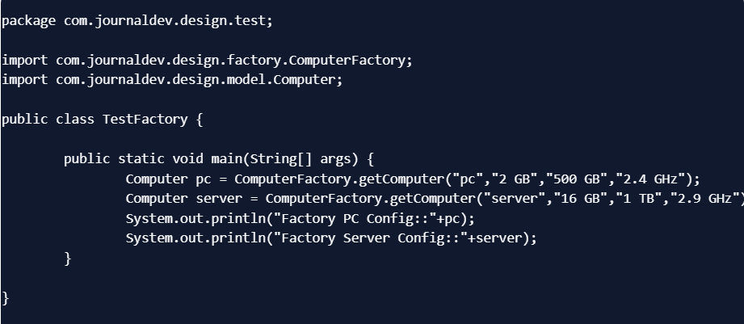
Output:

Factory Design Pattern Advantages
Factory design pattern provides approach to code for interface rather than implementation.
Factory pattern removes the instantiation of actual implementation classes from client code. Factory pattern makes our code more robust, less coupled and easy to extend. For example, we can easily change PC class implementation because client program is unaware of this.
Factory pattern provides abstraction between implementation and client classes through inheritance.
Factory Design Pattern Examples in JDK
java.util.Calendar, ResourceBundle and NumberFormat getInstance() methods uses Factory pattern.
valueOf() method in wrapper classes like Boolean, Integer etc.

Abstract Factory:
If you are familiar with factory design pattern in java, you will notice that we have a single Factory class. This factory class returns different subclasses based on the input provided and factory class uses if-else or switch statement to achieve this. In the Abstract Factory pattern, we get rid of if-else block and have a factory class for each sub-class. Then an Abstract Factory class that will return the sub-class based on the input factory class. At first, it seems confusing but once you see the implementation, it’s really easy to grasp and understand the minor difference between Factory and Abstract Factory pattern. Like our factory pattern, we will use the same superclass and sub-classes.
Abstract Factory Design Pattern Super Class and Subclasses
Computer.java
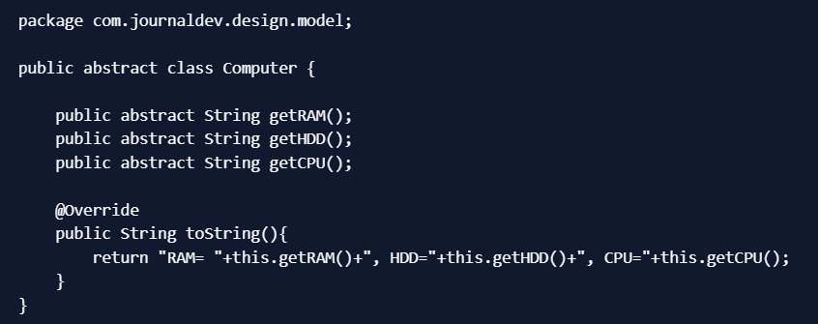
PC.java
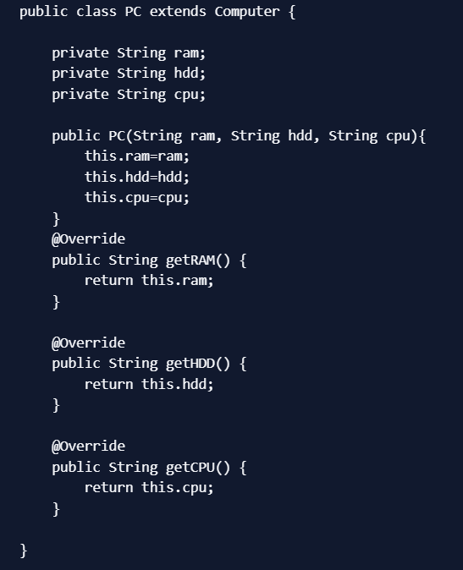
Server.java
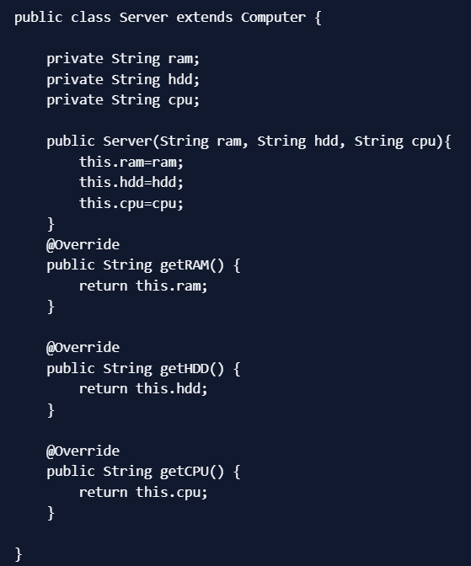
Factory Class for Each subclass
First of all we need to create a Abstract Factory interface or abstract class.
ComputerAbstractFactory.java
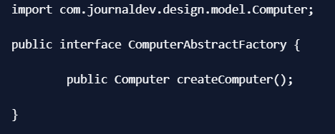
Notice that createComputer() method is returning an instance of super class Computer. Now our factory classes will implement this interface and return their respective sub-class. PCFactory.java
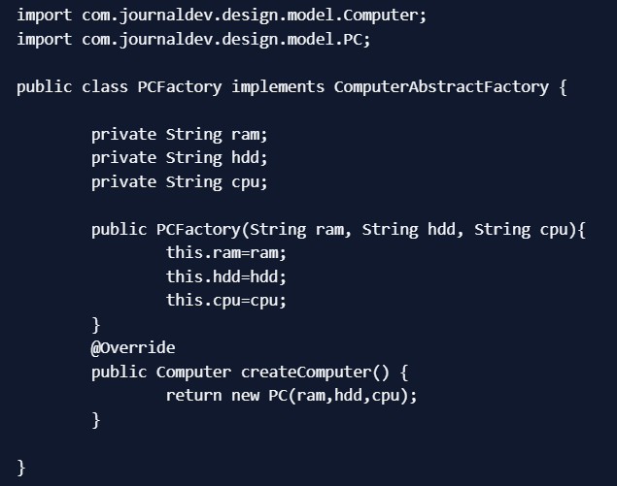

Similarly we will have a factory class for Server subclass. ServerFactory.java
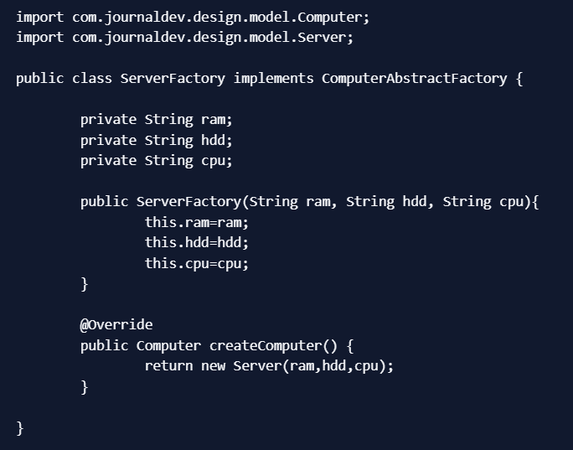
Now we will create a consumer class that will provide the entry point for the client classes to create sub-classes. ComputerFactory.java
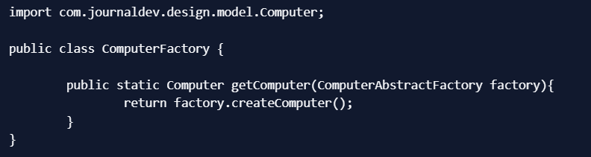
Notice that its a simple class and getComputer method is accepting ComputerAbstractFactory argument and returning Computer object. At this point the implementation must be getting clear. Let’s write a simple test method and see how to use the abstract factory to get the instance of sub-classes.
TestDesignPatterns.java
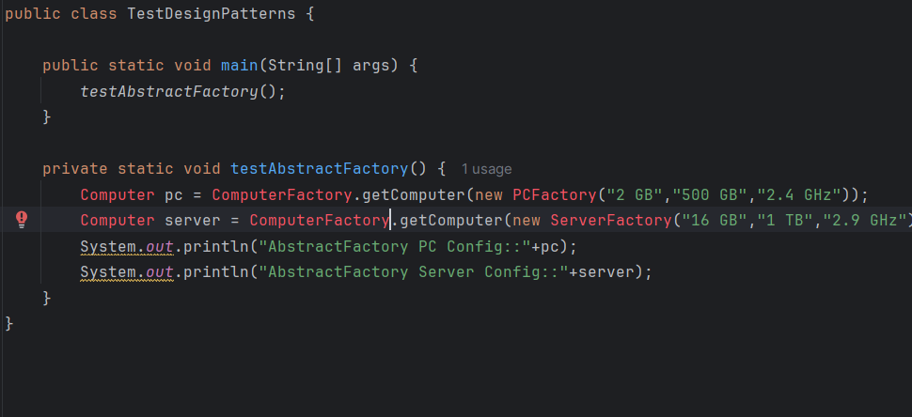
Output of the above program will be:

Abstract Factory Design Pattern Benefits
Abstract Factory design pattern provides approach to code for interface rather than implementation.
Abstract Factory pattern is “factory of factories” and can be easily extended to accommodate more products, for example we can add another sub-class Laptop and a factory LaptopFactory.
Abstract Factory pattern is robust and avoid conditional logic of Factory pattern.
Abstract Factory Design Pattern Examples in JDK
javax.xml.parsers.DocumentBuilderFactory#newInstance()
javax.xml.transform.TransformerFactory#newInstance()
javax.xml.xpath.XPathFactory#newInstance()

Builder Design Pattern:
Builder pattern was introduced to solve some of the problems with Factory and Abstract Factory design patterns when the Object contains a lot of attributes. There are three major issues with Factory and Abstract Factory design patterns when the Object contains a lot of attributes.
Too Many arguments to pass from client program to the Factory class that can be error prone because most of the time, the type of arguments are same and from client side its hard to maintain the order of the argument.
Some of the parameters might be optional but in Factory pattern, we are forced to send all the parameters and optional parameters need to send as NULL.
If the object is heavy and its creation is complex, then all that complexity will be part of Factory classes that is confusing.
Builder Design Pattern in Java
Let’s see how we can implement builder design pattern in java.
First of all we need to create a static nested class and then copy all the arguments from the outer class to the Builder class. We should follow the naming convention and if the class name is Computer then builder class should be named as ComputerBuilder.
Java Builder class should have a public constructor with all the required attributes as parameters.
Java Builder class should have methods to set the optional parameters and it should return the same Builder object after setting the optional attribute.
The final step is to provide a build() method in the builder class that will return the Object needed by client program. For this we need to have a private constructor in the Class with Builder class as argument.
Here is the sample builder pattern example code where we have a Computer class and ComputerBuilder class to build it.
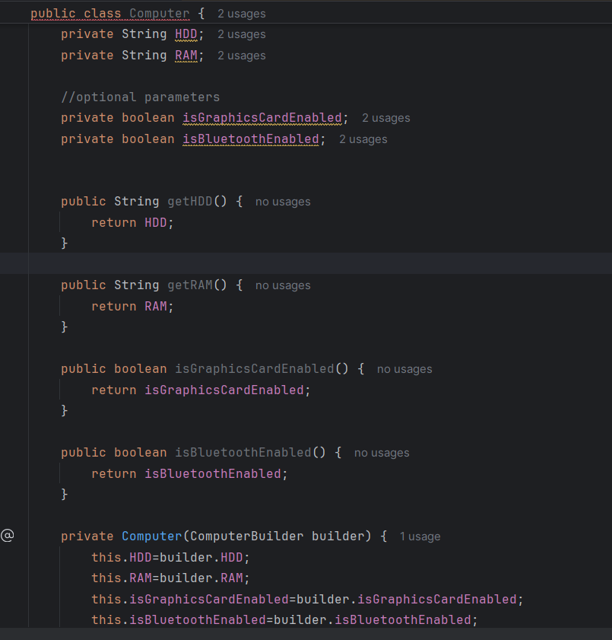
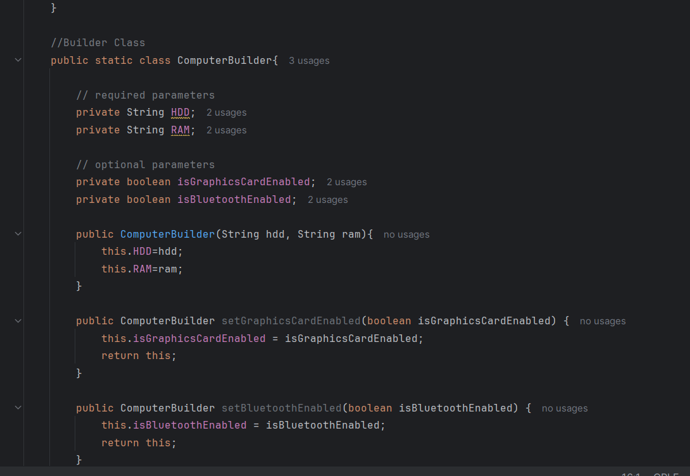
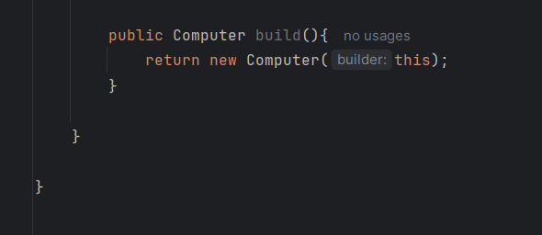
Notice that Computer class has only getter methods and no public constructor. So the only way to get a Computer object is through the ComputerBuilder class. Here is a builder pattern example test program showing how to use Builder class to get the object
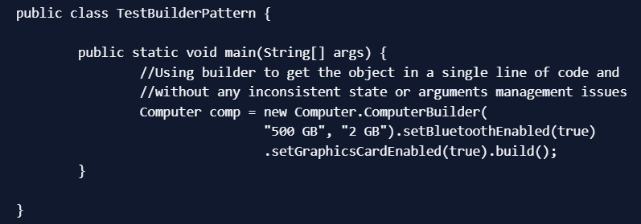
Prototype Design Pattern in Java:
Prototype design pattern is used when the Object creation is a costly affair and requires a lot of time and resources and you have a similar object already existing. Prototype pattern provides a mechanism to copy the original object to a new object and then modify it according to our needs. Prototype design pattern uses java cloning to copy the object.
Prototype Design Pattern Example
It would be easy to understand prototype design pattern with an example. Suppose we have an Object that loads data from database. Now we need to modify this data in our program multiple times, so it’s not a good idea to create the Object using new keyword and load all the data again from database. The better approach would be to clone the existing object into a new object and then do the data manipulation. Prototype design pattern mandates that the Object which you are copying should provide the copying feature. It should not be done by any other class. However whether to use shallow or deep copy of the Object properties depends on the requirements and its a design decision. Here is a sample program showing Prototype design pattern example in java. Employees.java
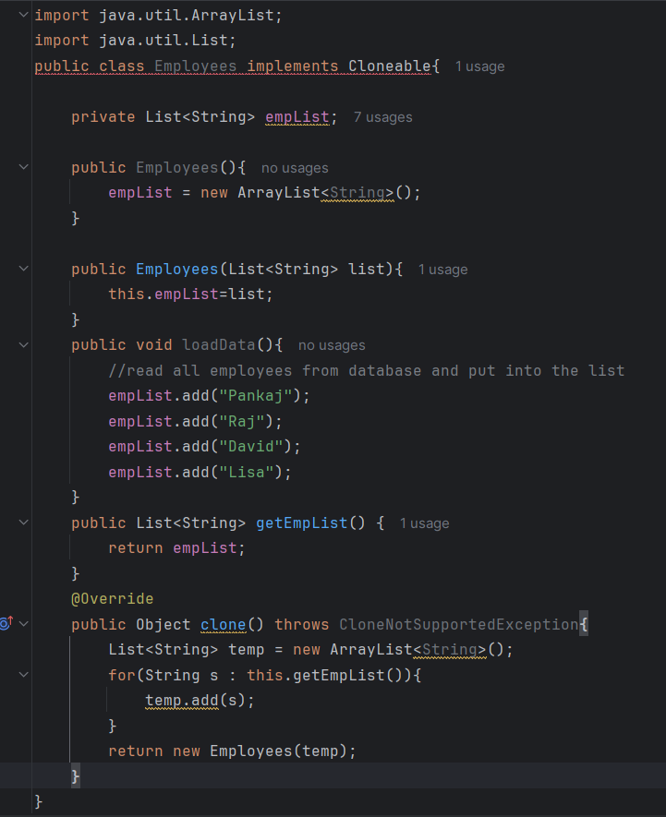

Notice that the clone method is overridden to provide a deep copy of the employees list. Here is the prototype design pattern example test program that will show the benefit of prototype pattern. PrototypePatternTest.java
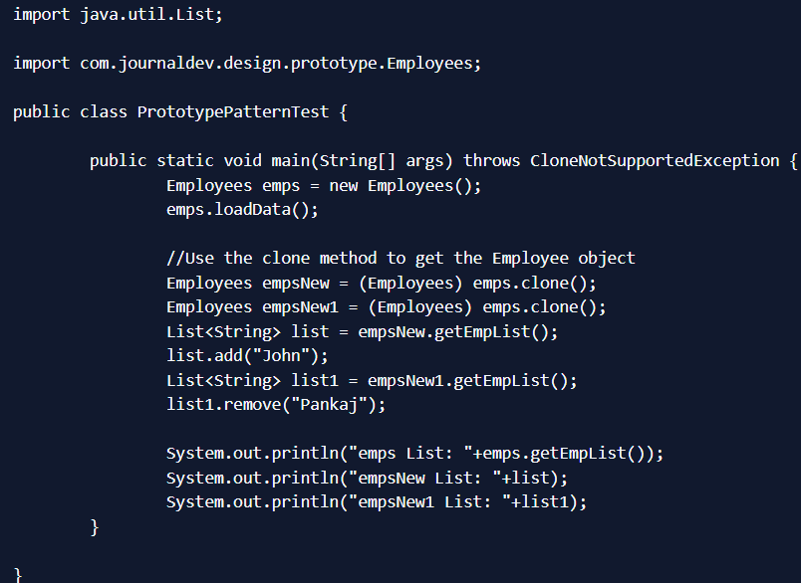
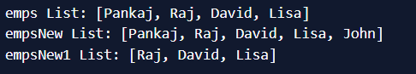
If the object cloning was not provided, we will have to make database call to fetch the employee list every time. Then do the manipulations that would have been resource and time consuming. That’s all for prototype design pattern in java.

Structural Design Patterns :
Structural design patterns provide different ways to create a Class structure (for example, using inheritance and composition to create a large Object from small Objects).
2.1 Adapter Design Pattern:
It is used to two unrelated interfaces can work together. The object that joins these unrelated interface is called an Adapter.
One of the great real life example of Adapter design pattern is mobile charger. Mobile battery needs 3 volts to charge but the normal socket produces either 120V (US) or 240V (India). So the mobile charger works as an adapter between mobile charging socket and the wall socket. We will try to implement multi-adapter using adapter design pattern in this tutorial. So first of all we will have two classes - Volt (to measure volts) and Socket (producing constant volts of 120V).
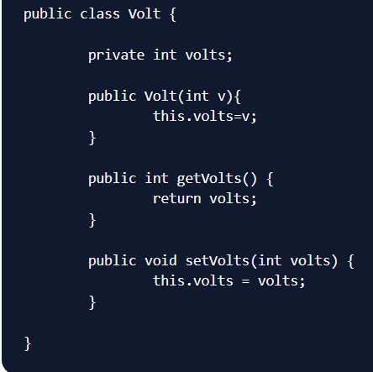
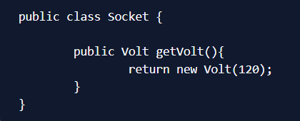
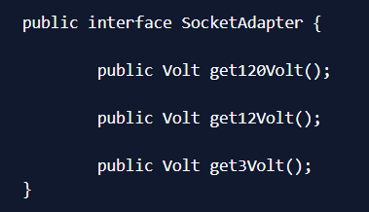

Two Way Adapter Pattern:
While implementing Adapter pattern, there are two approaches - class adapter and object adapter - however both these approaches produce same result.
Class Adapter - This form uses java inheritance and extends the source interface, in our case Socket class.
Object Adapter - This form uses Java Composition and adapter contains the source object.
Adapter Design Pattern - Class Adapter
Here is the class adapter approach implementation of our adapter.
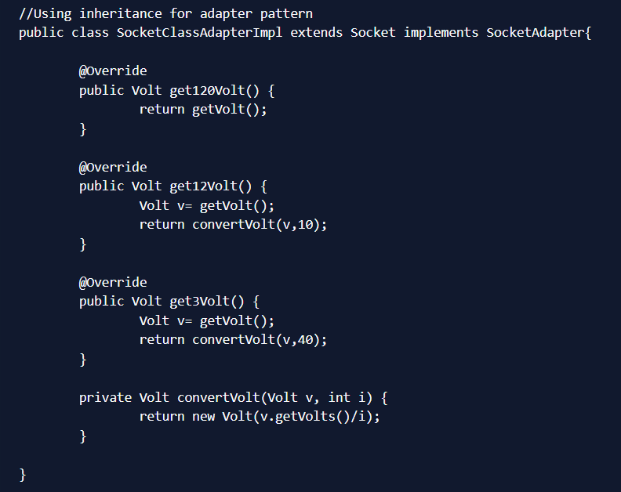

Adapter Design Pattern - Object Adapter Implementation
Here is the Object adapter implementation of our adapter.
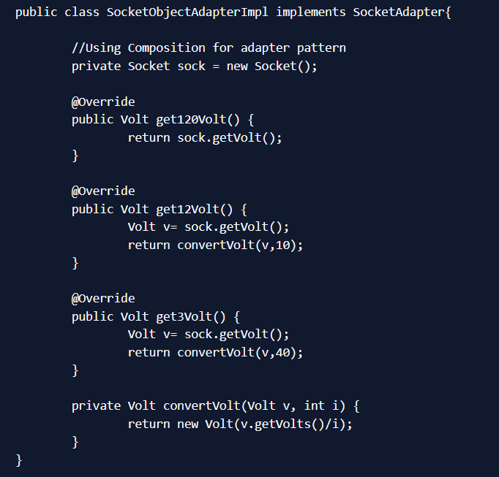
Notice that both the adapter implementations are almost same and they implement the SocketAdapter interface. The adapter interface can also be an abstract class. Here is a test program to consume our adapter design pattern implementation.
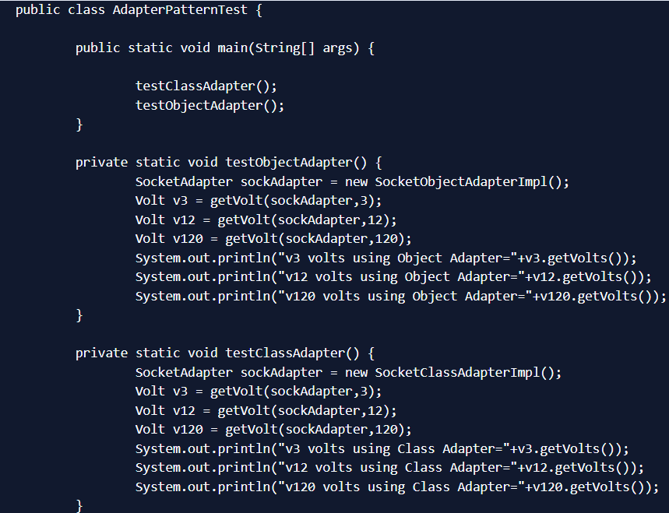
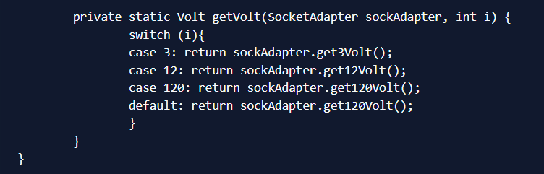
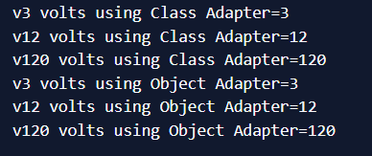

Composite Design Pattern :
When we need to create a structure in a way that the objects in the structure has to be treated the same way, we can apply composite design pattern.
It is used to represent part-whole hierarchies (tree structures).
Lets understand it with a real life example - A Shape is a structure that consists of Objects such as Circle, Lines, Triangle etc. When we fill the drawing with color (say Red), the same color also gets applied to the Objects in the drawing. Here drawing is made up of different parts and they all have same operations.
Composite Pattern consists of following objects.
- Base Component - Base component is the interface for all objects in the composition, client program uses base component to work with the objects in the composition. It can be an interface or an abstract class with some methods common to all the objects.
- Leaf - Defines the behaviour for the elements in the composition. It is the building block for the composition and implements base component. It doesn’t have references to other Components.
- Composite - It consists of leaf elements and implements the operations in base component.
Here I am applying composite design pattern for the drawing scenario.

Composite Pattern Base Component
Composite pattern base component defines the common methods for leaf and composites. We can create a class Shape with a method draw(String fillColor) to draw the shape with given color. Shape.java
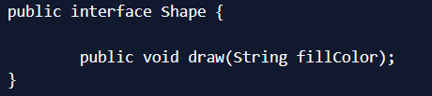
Composite Design Pattern Leaf Objects
Composite design pattern leaf implements base component, and these are the building block for the composite. We can create multiple leaf objects such as Triangle, Circle etc. Triangle.java
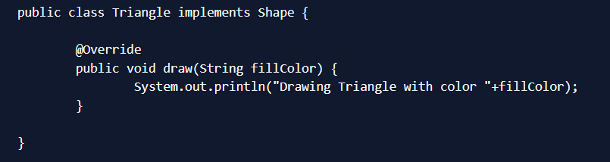
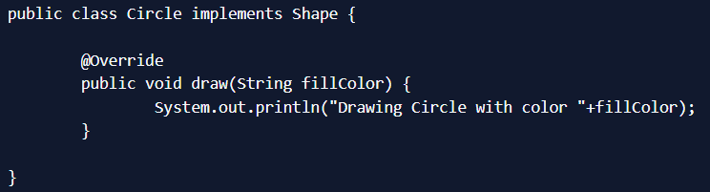
Composite object
A composite object contains group of leaf objects and we should provide some helper methods to add or delete leafs from the group. We can also provide a method to remove all the elements from the group. Drawing.java
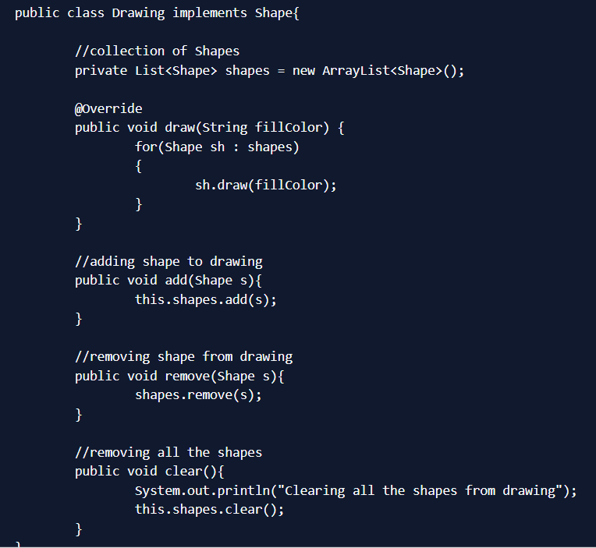
Our composite pattern implementation is ready and we can test it with a client program.
Composite Design Pattern Client Program
TestCompositePattern.java

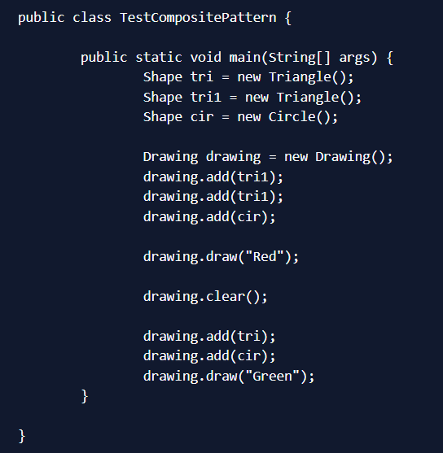

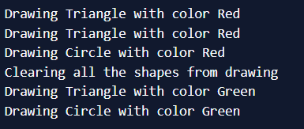
Composite Pattern Important Points
Composite pattern should be applied only when the group of objects should behave as the single object.
Composite design pattern can be used to create a tree like structure.
java.awt.Container#add(Component) is a great example of Composite pattern in java and used a lot in Swing.

Proxy Design Pattern:
Proxy design pattern intent to Provide a surrogate or placeholder for another object to control access to it. The definition itself is very clear and proxy design pattern is used when we want to provide controlled access of a functionality. Let’s say we have a class that can run some command on the system. Now if we are using it, its fine but if we want to give this program to a client application, it can have severe issues because client program can issue command to delete some system files or change some settings that you don’t want. Here a proxy class can be created to provide controlled access of the program.

Proxy Design Pattern - Main Class
Since we code Java in terms of interfaces, here is our interface and its implementation class. CommandExecutor.java

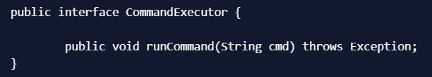
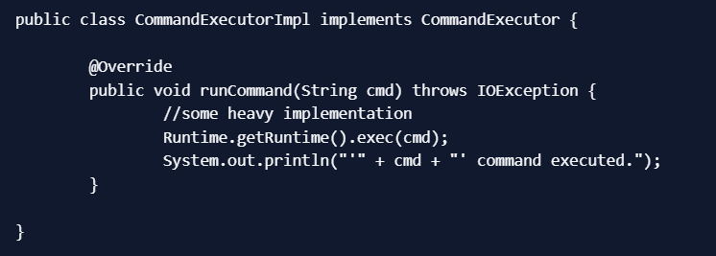

Proxy Design Pattern - Proxy Class
Now we want to provide only admin users to have full access of above class, if the user is not admin then only limited commands will be allowed. Here is our very simple proxy class implementation. CommandExecutorProxy.java

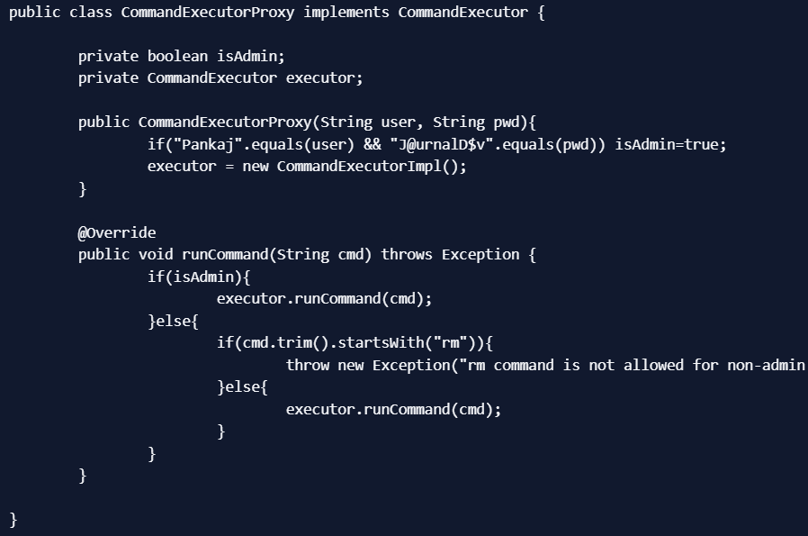

Proxy Design Pattern Client Program
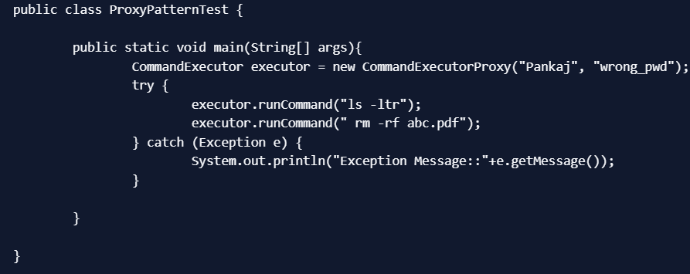

Proxy design pattern common uses are to control access or to provide a wrapper implementation for better performance. Java RMI package uses proxy pattern. That’s all for proxy design pattern in java.

Facade Design Pattern:
It is used to help client applications to easily interact with the system.
Provide a unified interface to a set of interfaces in a subsystem. Facade Pattern defines a higher-level interface that makes the subsystem easier to use.

Suppose we have an application with set of interfaces to use MySql/Oracle database and to generate different types of reports, such as HTML report, PDF report etc. So we will have different set of interfaces to work with different types of database. Now a client application can use these interfaces to get the required database connection and generate reports. But when the complexity increases or the interface behavior names are confusing, client application will find it difficult to manage it. So we can apply Facade design pattern here and provide a wrapper interface on top of the existing interface to help client application.
Facade Design Pattern - Set of Interfaces:
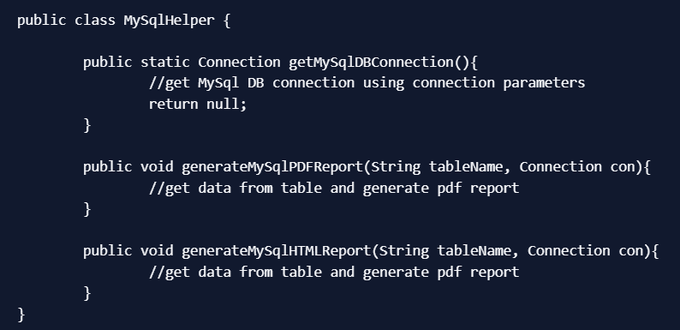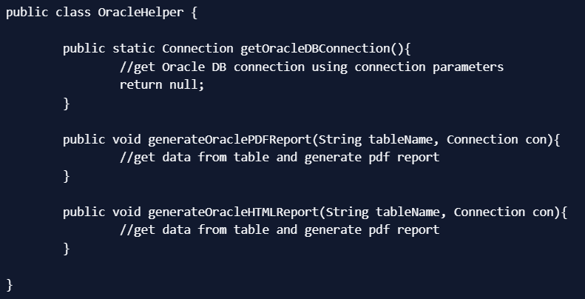
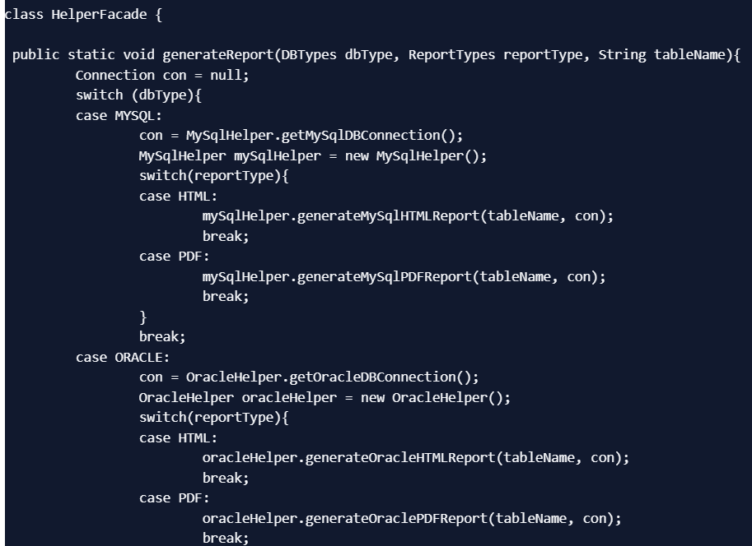
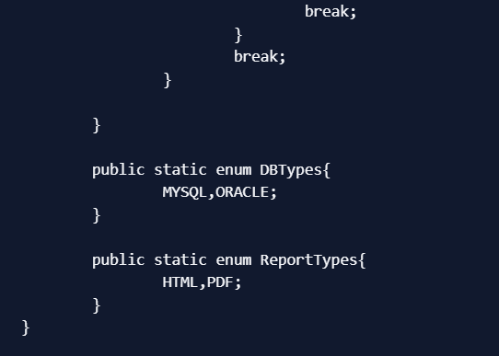
Now lets see client code without using Facade pattern and using Facade pattern interface.
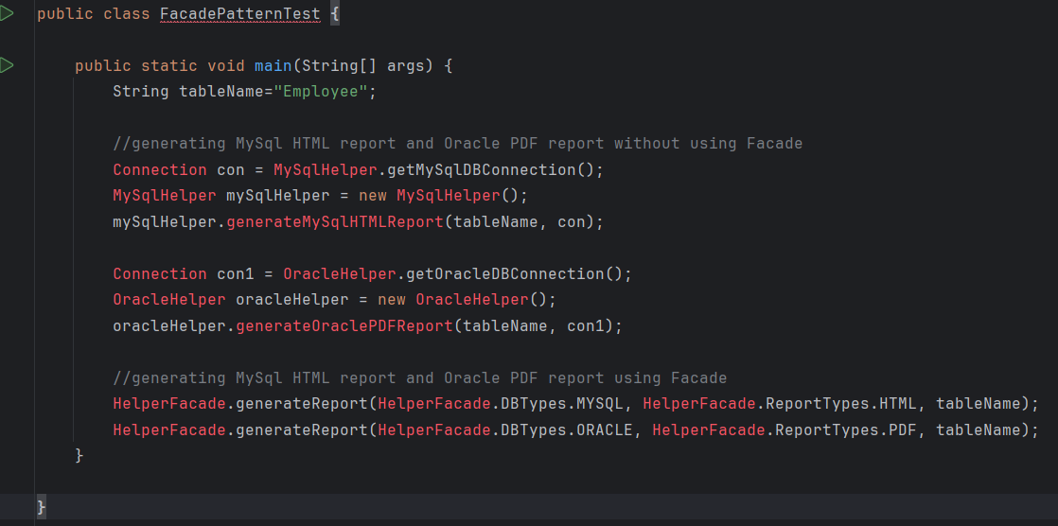
As you can see that using Facade pattern interface is a lot easier and cleaner way to avoid having a lot of logic at client side. JDBC Driver Manager class to get the database connection is a wonderful example of facade design pattern.
Facade Design Pattern Important Points
- Facade design pattern is more like a helper for client applications, it doesn’t hide subsystem interfaces from the client. Whether to use Facade or not is completely dependent on client code.
- Facade design pattern can be applied at any point of development, usually when the number of interfaces grow and system gets complex.
- Subsystem interfaces are not aware of Facade and they shouldn’t have any reference of the Facade interface.
- Facade design pattern should be applied for similar kind of interfaces, its purpose is to provide a single interface rather than multiple interfaces that does the similar kind of jobs.
- We can use Factory pattern with Facade to provide better interface to client systems.

Bridge Design Pattern in Java:
When we have interface hierarchies in both interfaces as well as implementations, then bridge design pattern is used to decouple the interfaces from implementation and hiding the implementation details from the client programs.
“Decouple an abstraction from its implementation so that the two can vary independently”
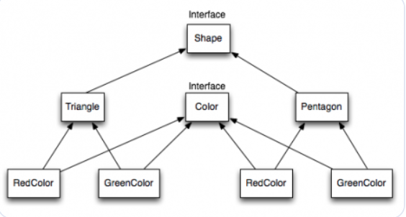

Notice the bridge between Shape and Color interfaces and use of composition in implementing the bridge pattern. Here is the java code for Shape and Color interfaces. Color.java
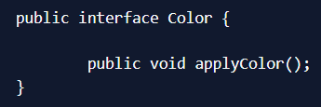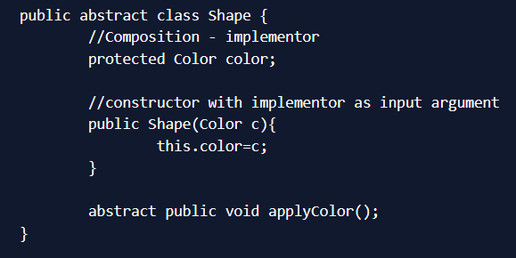

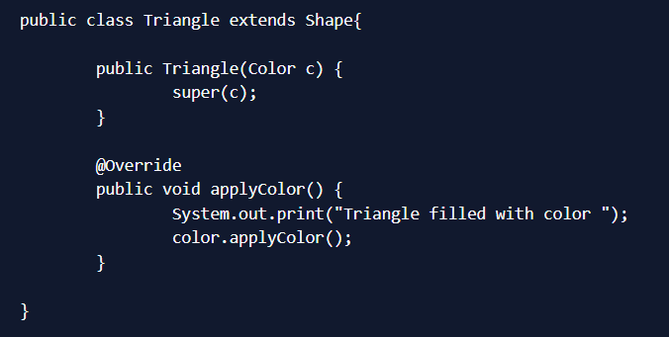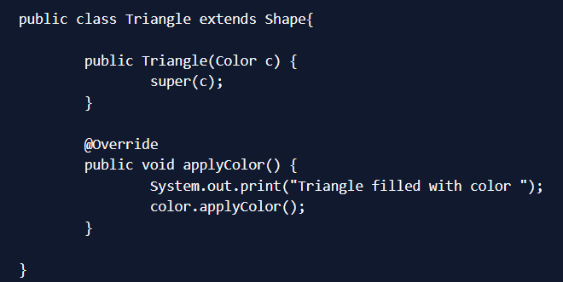

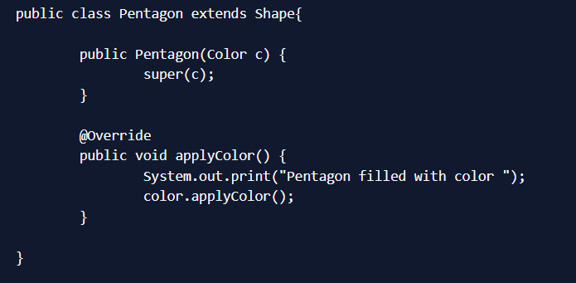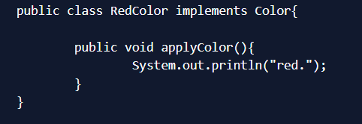

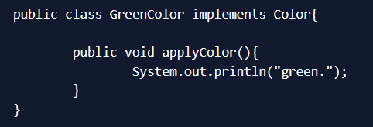
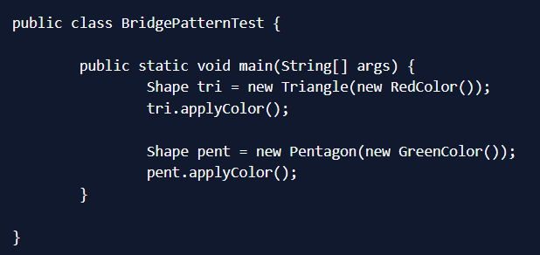
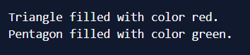
Bridge design pattern can be used when both abstraction and implementation can have different hierarchies independently and we want to hide the implementation from the client application.
Decorator Design Pattern:
is used to modify the functionality of an object at runtime. At the same time other instances of the same class will not be affected by this, so individual object gets the modified behavior.
We use inheritance or composition to extend the behavior of an object but this is done at compile time and its applicable to all the instances of the class. We can’t add any new functionality of remove any existing behavior at runtime - this is when Decorator pattern comes into picture. Suppose we want to implement different kinds of cars - we can create interface Car to define the assemble method and then we can have a Basic car, further more we can extend it to Sports car and Luxury Car. The implementation hierarchy will look like below image.
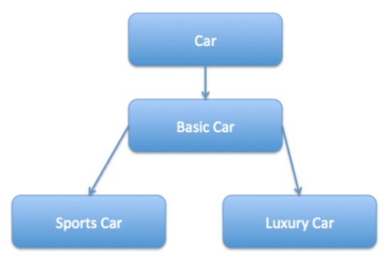
But if we want to get a car at runtime that has both the features of sports car and luxury car, then the implementation gets complex and if further more we want to specify which features should be added first, it gets even more complex. Now imagine if we have ten different kind of cars, the implementation logic using inheritance and composition will be impossible to manage. To solve this kind of programming situation, we apply decorator pattern in java. We need to have following types to implement decorator design pattern.
Component Interface - The interface or abstract class defining the methods that will be implemented. In our case Car will be the component interface.

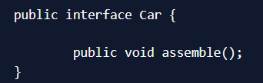
Component Implementation - The basic implementation of the component interface. We can have BasicCar class as our component implementation.
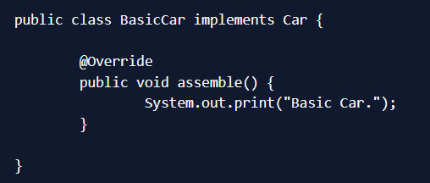
Decorator - Decorator class implements the component interface and it has a HAS-A relationship with the component interface. The component variable should be accessible to the child decorator classes, so we will make this variable protected.
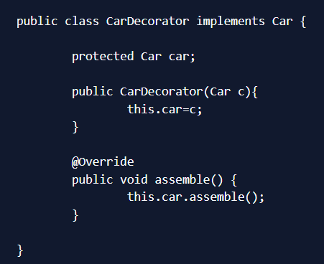
Concrete Decorators - Extending the base decorator functionality and modifying the component behavior accordingly. We can have concrete decorator classes as LuxuryCar and SportsCar.
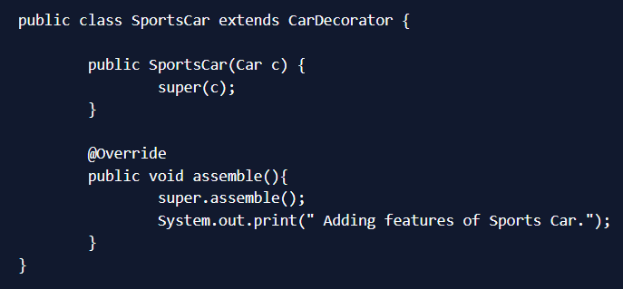
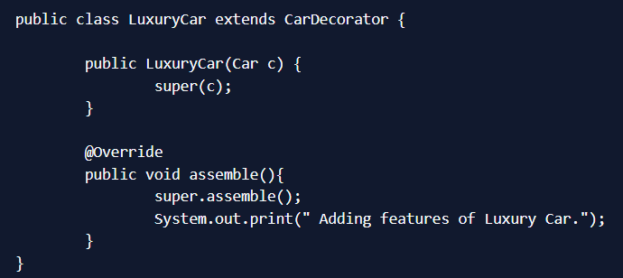
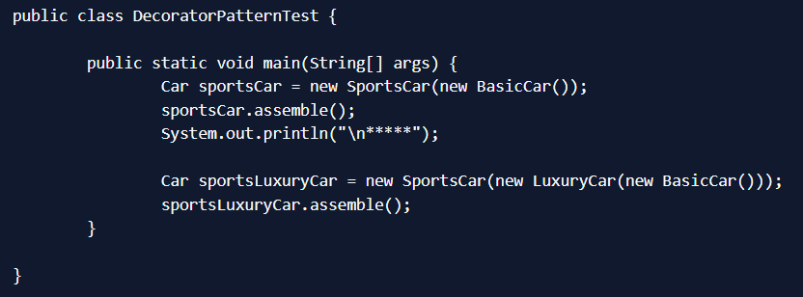
Notice that client program can create different kinds of Object at runtime and they can specify the order of execution too. Output of above test program is:
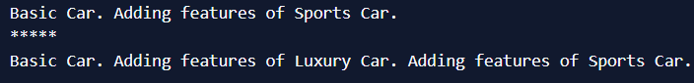
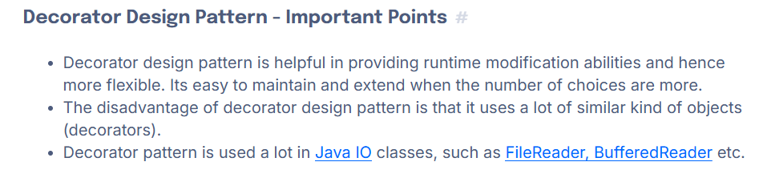
: Behavioral Design Patterns :
Behavioral patterns provide a solution for better interaction between objects and how to provide loose-coupling and flexibility to extend easily.

Template Method Design Pattern :-
It is used to create a method stub and deferring some of the steps of implementation to the subclasses.
Template method defines the steps to execute an algorithm and it can provide default implementation that might be common for all or some of the subclasses. Let’s understand this pattern with an example, suppose we want to provide an algorithm to build a house. The steps need to be performed to build a house are - building foundation, building pillars, building walls and windows. The important point is that the we can’t change the order of execution because we can’t build windows before building the foundation. So in this case we can create a template method that will use different methods to build the house. Now building the foundation for a house is same for all type of houses, whether its a wooden house or a glass house. So we can provide base implementation for this, if subclasses want to override this method, they can but mostly it’s common for all the types of houses. To make sure that subclasses don’t override the template method, we should make it final.

Template Method Abstract Class:
Since we want some of the methods to be implemented by subclasses, we have to make our base class as abstract class. HouseTemplate.java
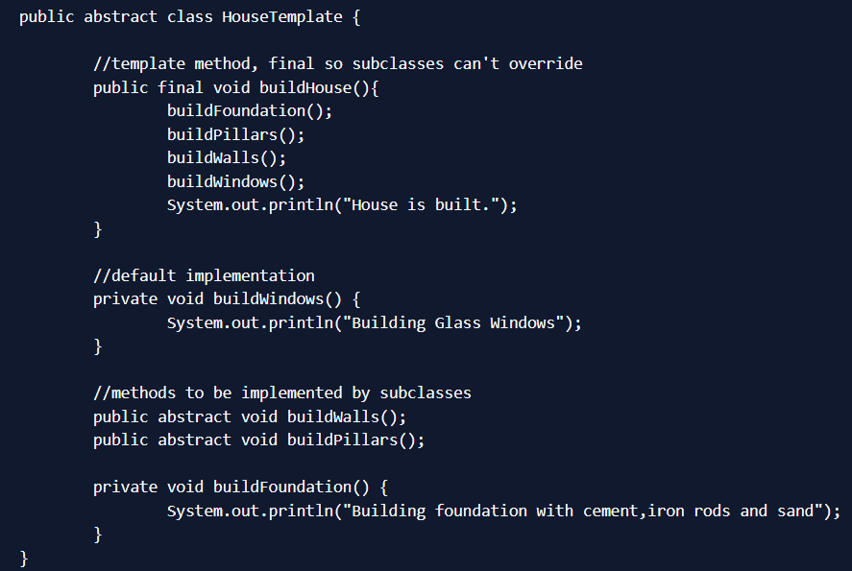
buildHouse() is the template method and defines the order of execution for performing several steps.
Template Method Concrete Classes
We can have different type of houses, such as Wooden House and Glass House. WoodenHouse.java
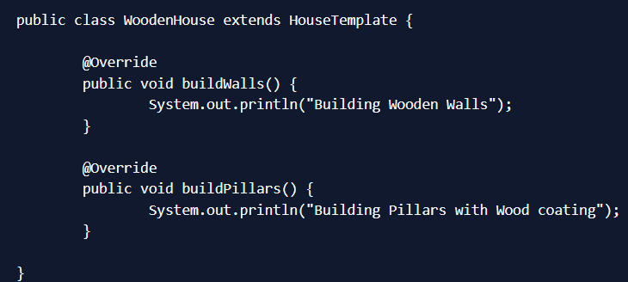
We could have overridden other methods also, but for simplicity I am not doing that. GlassHouse.java
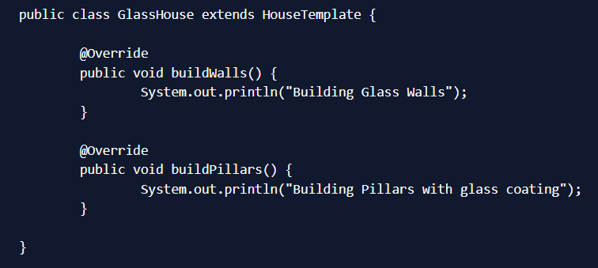

Template Method Design Pattern Client
Let’s test our template method pattern example with a test program. HousingClient.java
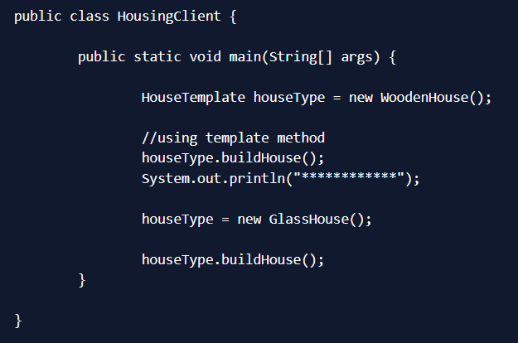
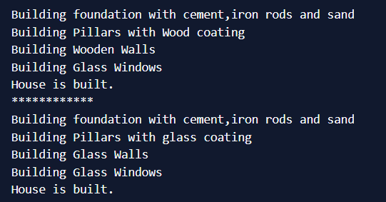
Template Method Design Pattern in JDK
All non-abstract methods of java.io.InputStream, java.io.OutputStream, java.io.Reader and java.io.Writer.
All non-abstract methods of java.util.AbstractList, java.util.AbstractSet and java.util.AbstractMap.
Chain of Responsibility Design Pattern:
Chain of responsibility pattern is used to achieve loose coupling in software design where a request from client is passed to a chain of objects to process them. Then the object in the chain will decide themselves who will be processing the request and whether the request is required to be sent to the next object in the chain or not.

Chain of Responsibility Pattern Example in JDK
Let’s see the example of chain of responsibility pattern in JDK and then we will proceed to implement a real life example of this pattern. We know that we can have multiple catch blocks in a try-catch block code. Here every catch block is kind of a processor to process that particular exception. So when any exception occurs in the try block, its send to the first catch block to process. If the catch block is not able to process it, it forwards the request to next object in chain i.e next catch block. If even the last catch block is not able to process it, the exception is thrown outside of the chain to the calling program.
Chain of Responsibility Design Pattern Example
One of the great example of Chain of Responsibility pattern is ATM Dispense machine. The user enters the amount to be dispensed and the machine dispense amount in terms of defined currency bills such as 50$, 20$, 10$ etc. If the user enters an amount that is not multiples of 10, it throws error. We will use Chain of Responsibility pattern to implement this solution. The chain will process the request in the same order as below image.
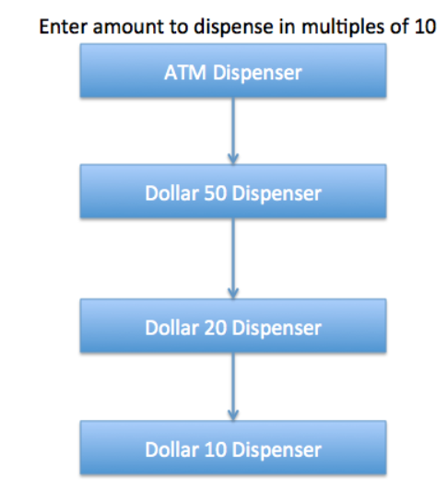
Note that we can implement this solution easily in a single program itself but then the complexity will increase and the solution will be tightly coupled. So we will create a chain of dispense systems to dispense bills of 50$, 20$ and 10$.
Chain of Responsibility Design Pattern - Base Classes and Interface
We can create a class Currency that will store the amount to dispense and used by the chain implementations. Currency.java
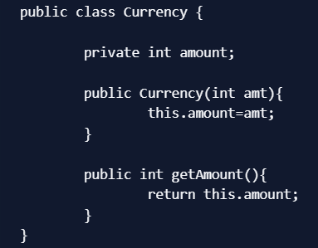
The base interface should have a method to define the next processor in the chain and the method that will process the request. Our ATM Dispense interface will look like below. DispenseChain.java
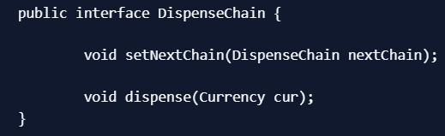
Chain of Responsibilities Pattern - Chain Implementations
We need to create different processor classes that will implement the DispenseChain interface and provide implementation of dispense methods. Since we are developing our system to work with three types of currency bills - 50$, 20$ and 10$, we will create three concrete implementations. Dollar50Dispenser.java
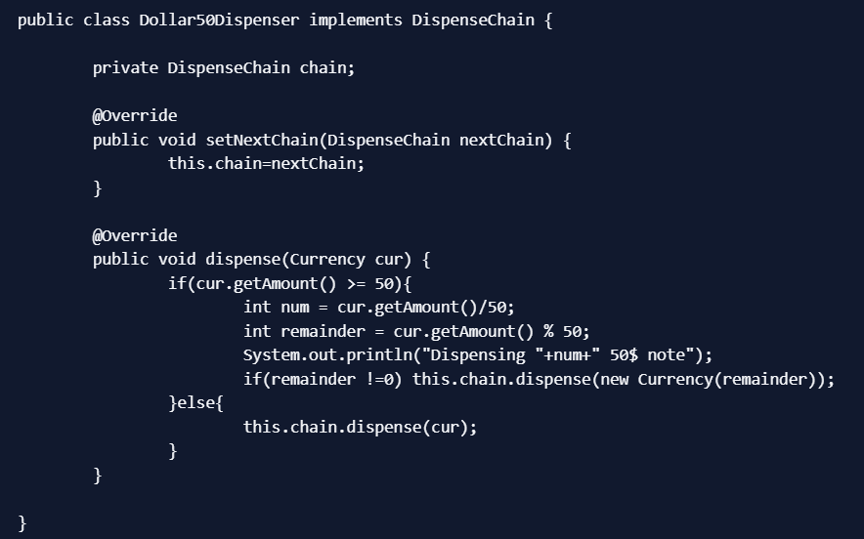
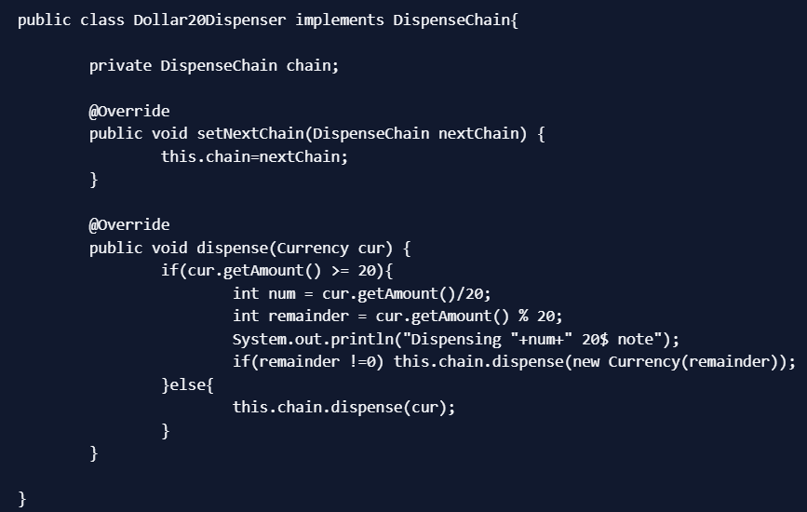
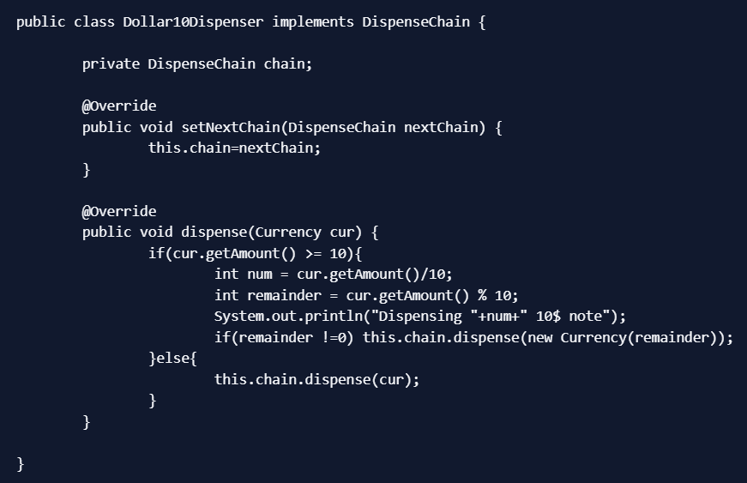
The important point to note here is the implementation of dispense method. You will notice that every implementation is trying to process the request and based on the amount, it might process some or full part of it. If one of the chain not able to process it fully, it sends the request to the next processor in chain to process the remaining request. If the processor is not able to process anything, it just forwards the same request to the next chain.
Chain of Responsibilities Design Pattern - Creating the Chain
This is a very important step and we should create the chain carefully, otherwise a processor might not be getting any request at all. For example, in our implementation if we keep the first processor chain as Dollar10Dispenser and then Dollar20Dispenser, then the request will never be forwarded to the second processor and the chain will become useless. Here is our ATM Dispenser implementation to process the user requested amount. ATMDispenseChain.java
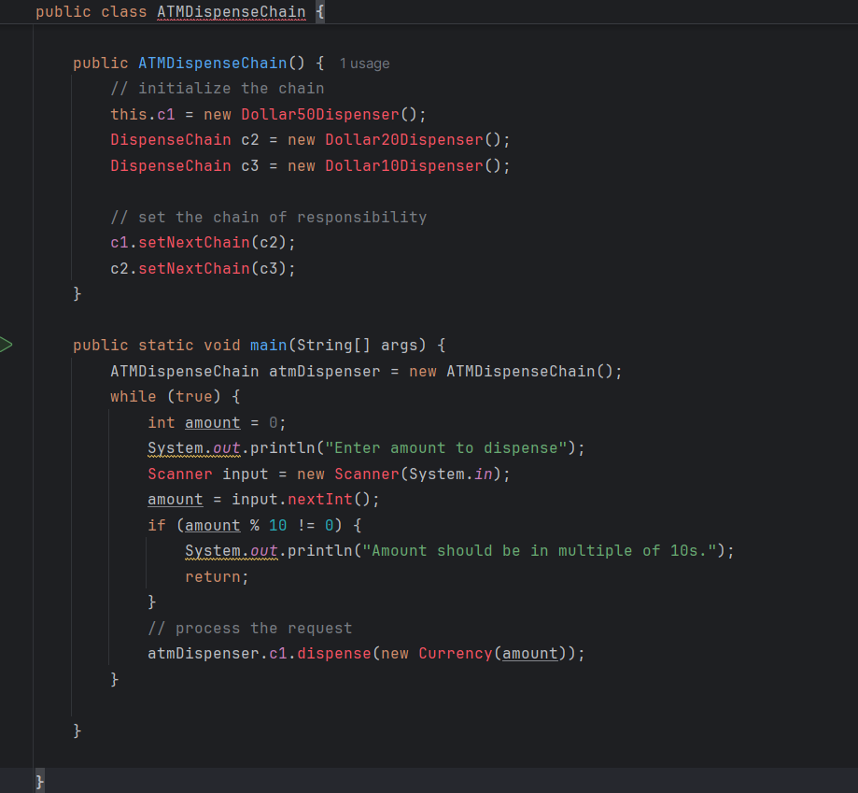
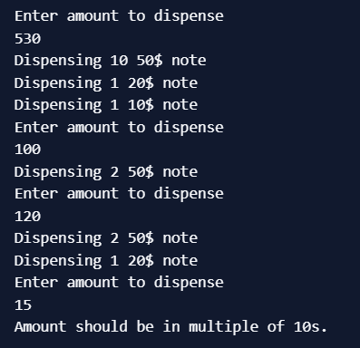
Chain of Responsibility Design Pattern Important Points
- Client doesn’t know which part of the chain will be processing the request and it will send the request to the first object in the chain. For example, in our program ATMDispenseChain is unaware of who is processing the request to dispense the entered amount.
- Each object in the chain will have it’s own implementation to process the request, either full or partial or to send it to the next object in the chain.
- Every object in the chain should have reference to the next object in chain to forward the request to, its achieved by java composition.
- Creating the chain carefully is very important otherwise there might be a case that the request will never be forwarded to a particular processor or there are no objects in the chain who are able to handle the request. In my implementation, I have added the check for the user entered amount to make sure it gets processed fully by all the processors but we might not check it and throw exception if the request reaches the last object and there are no further objects in the chain to forward the request to. This is a design decision.
- Chain of Responsibility design pattern is good to achieve lose coupling but it comes with the trade-off of having a lot of implementation classes and maintenance problems if most of the code is common in all the implementations.
Chain of Responsibility Pattern Examples in JDK
java.util.logging.Logger#log() javax.servlet.Filter#doFilter()
Observer Design Pattern:
It is useful when you are interested in the state of an object and want to get notified whenever there is any change. In observer pattern, the object that watch on the state of another object are called Observer and the object that is being watched is called Subject.
“Define a one-to-many dependency between objects so that when one object changes state, all its dependents are notified and updated automatically.”

Subject contains a list of observers to notify of any change in it’s state, so it should provide methods using which observers can register and unregister themselves. Subject also contain a method to notify all the observers of any change and either it can send the update while notifying the observer or it can provide another method to get the update. Observer should have a method to set the object to watch and another method that will be used by Subject to notify them of any updates. Java provides inbuilt platform for implementing Observer pattern through java.util.Observable class and java.util.Observer interface. However it’s not widely used because the implementation is really simple and most of the times we don’t want to end up extending a class just for implementing Observer pattern as java doesn’t provide multiple inheritance in classes. Java Message Service (JMS) uses Observer design pattern along with Mediator pattern to allow applications to subscribe and publish data to other applications. Model-View-Controller (MVC) frameworks also use Observer pattern where Model is the Subject and Views are observers that can register to get notified of any change to the model.

Observer Pattern Java Example
For our observer pattern java program example, we would implement a simple topic and observers can register to this topic. Whenever any new message will be posted to the topic, all the registers observers will be notified and they can consume the message. Based on the requirements of Subject, here is the base Subject interface that defines the contract methods to be implemented by any concrete subject.
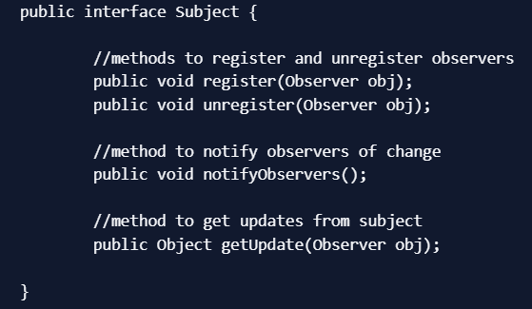
Next we will create contract for Observer, there will be a method to attach the Subject to the observer and another method to be used by Subject to notify of any change.
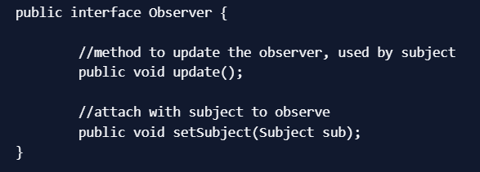
Now our contract is ready, let’s proceed with the concrete implementation of our topic.
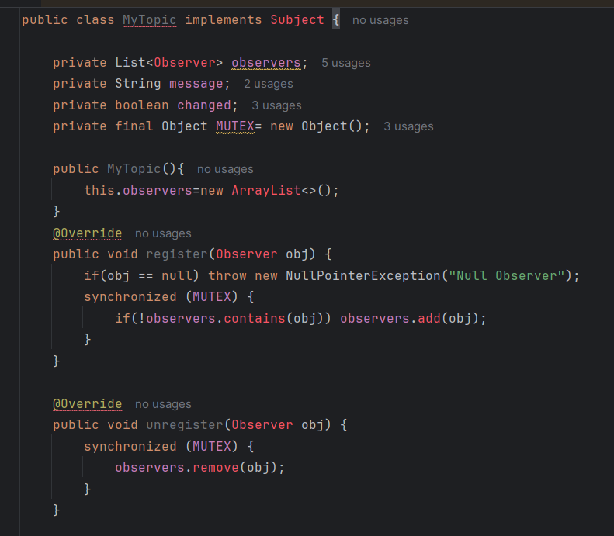
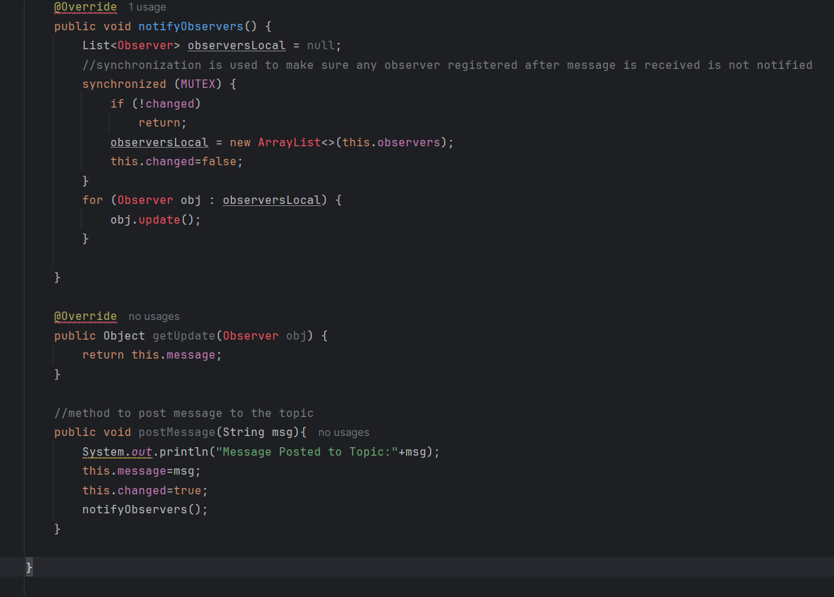
The method implementation to register and unregister an observer is very simple, the extra method is postMessage() that will be used by client application to post String message to the topic. Notice the boolean variable to keep track of the change in the state of topic and used in notifying observers. This variable is required so that if there is no update and somebody calls notifyObservers() method, it doesn’t send false notifications to the observers. Also notice the use of synchronization in notifyObservers() method to make sure the notification is sent only to the observers registered before the message is published to the topic. Here is the implementation of Observers that will watch over the subject.
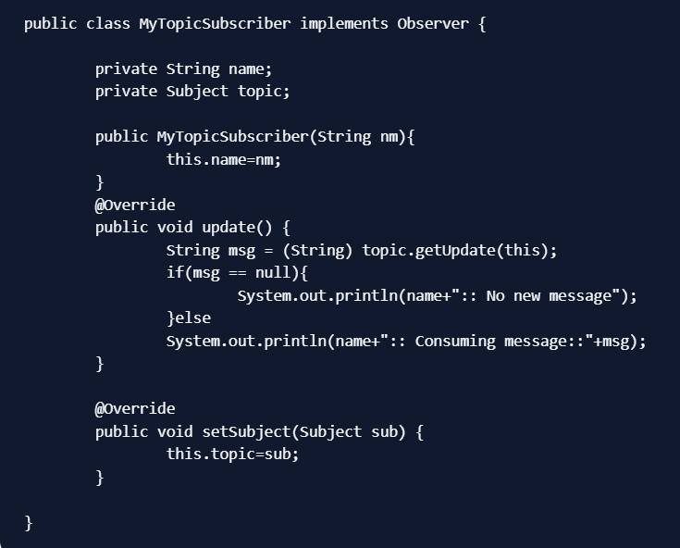
Notice the implementation of update() method where it’s calling Subject getUpdate() method to get the message to consume. We could have avoided this call by passing message as argument to update() method. Here is a simple test program to consume our topic implementation.
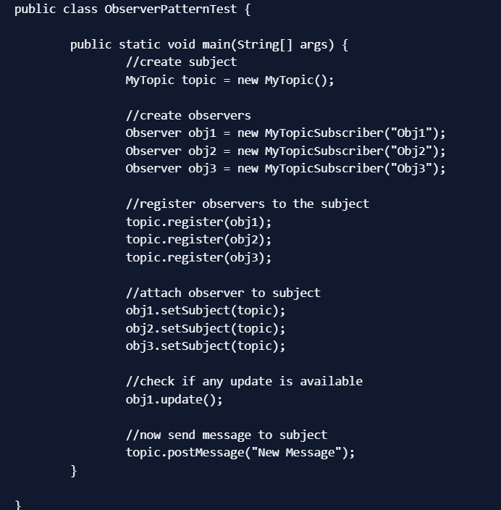
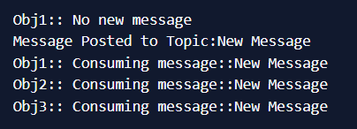
Observer design pattern is also called as publish-subscribe pattern. Some of it’s implementations are;
- java.util.EventListener in Swing
- javax.servlet.http.HttpSessionBindingListener
- Javax.servlet.http.HttpSessionAttributeListener

Strategy Pattern:
It is used when we have multiple algorithm for a specific task and client decides the actual implementation to be used at runtime.
Strategy pattern is also known as Policy Pattern. We define multiple algorithms and let client application pass the algorithm to be used as a parameter. One of the best example of strategy pattern is Collections.sort() method that takes Comparator parameter. Based on the different implementations of Comparator interfaces, the Objects are getting sorted in different ways. For our example, we will try to implement a simple Shopping Cart where we have two payment strategies - using Credit Card or using PayPal. First of all we will create the interface for our strategy pattern example, in our case to pay the amount passed as argument. PaymentStrategy.java
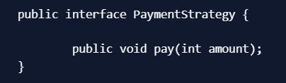
Now we will have to create concrete implementation of algorithms for payment using credit/debit card or through paypal.
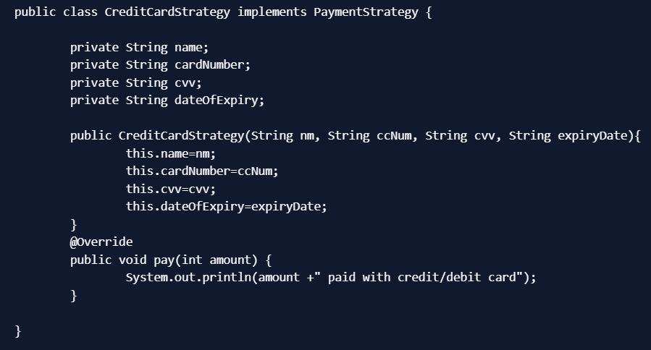
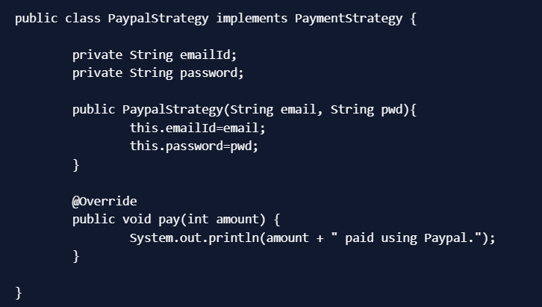
Now our strategy pattern example algorithms are ready. We can implement Shopping Cart and payment method will require input as Payment strategy.
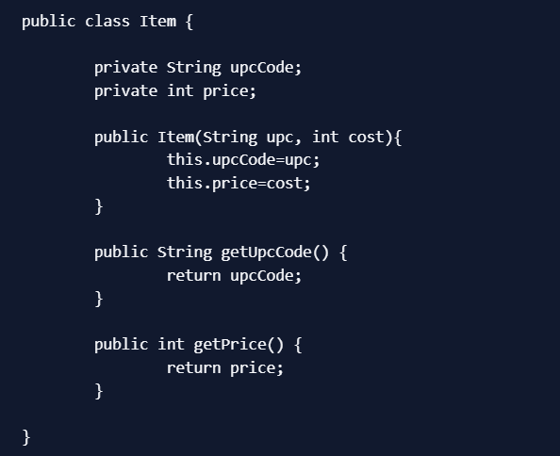
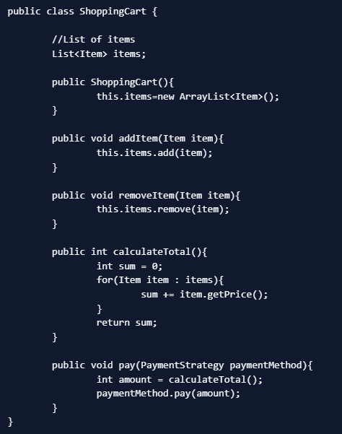
Notice that payment method of shopping cart requires payment algorithm as argument and doesn’t store it anywhere as instance variable. Let’s test our strategy pattern example setup with a simple program.
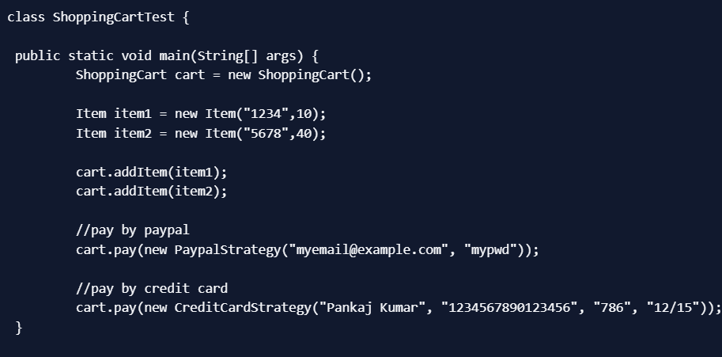
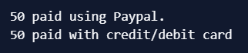
Strategy Design Pattern Important Points
- We could have used composition to create instance variable for strategies but we should avoid that as we want the specific strategy to be applied for a particular task. Same is followed in Collections.sort() and Arrays.sort() method that take comparator as argument.
- Strategy Pattern is very similar to State Pattern. One of the difference is that Context contains state as instance variable and there can be multiple tasks whose implementation can be dependent on the state whereas in strategy pattern strategy is passed as argument to the method and context object doesn’t have any variable to store it.
- Strategy pattern is useful when we have multiple algorithms for specific task and we want our application to be flexible to chose any of the algorithm at runtime for specific task.
Command Pattern:
Command Pattern is one of the Behavioral Design Pattern. Command design pattern is used to implement loose coupling in a request-response model.

In command pattern, the request is send to the invoker and invoker pass it to the encapsulated command object. Command object passes the request to the appropriate method of Receiver to perform the specific action. The client program create the receiver object and then attach it to the Command. Then it creates the invoker object and attach the command object to perform an action. Now when client program executes the action, it’s processed based on the command and receiver object.
Command Design Pattern Example
We will look at a real life scenario where we can implement Command pattern. Let’s say we want to provide a File System utility with methods to open, write and close file. This file system utility should support multiple operating systems such as Windows and Unix. To implement our File System utility, first of all we need to create the receiver classes that will actually do all the work. Since we code in terms of interface in java, we can have FileSystemReceiver interface and it’s implementation classes for different operating system flavors such as Windows, Unix, Solaris etc

Receiver Classes
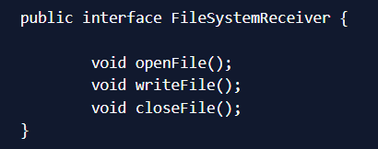
FileSystemReceiver interface defines the contract for the implementation classes. For simplicity, I am creating two flavors of receiver classes to work with Unix and Windows systems.
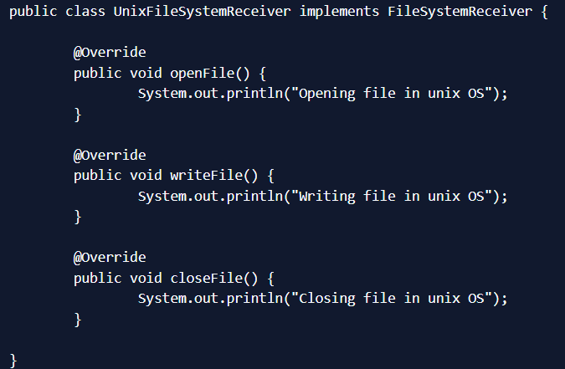
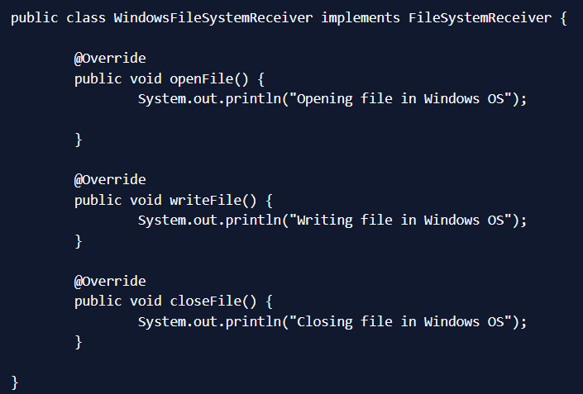
Did you noticed the Override annotation and if you wonder why it’s used, please read java annotations and override annotation benefits. Now that our receiver classes are ready, we can move to implement our Command classes.
Command Pattern Interface and Implementations
We can use interface or abstract class to create our base Command, it’s a design decision and depends on your requirement. We are going with interface because we don’t have any default implementations.
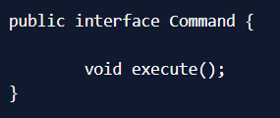
Now we need to create implementations for all the different types of action performed by the receiver. Since we have three actions we will create three Command implementations. Each Command implementation will forward the request to the appropriate method of receiver.
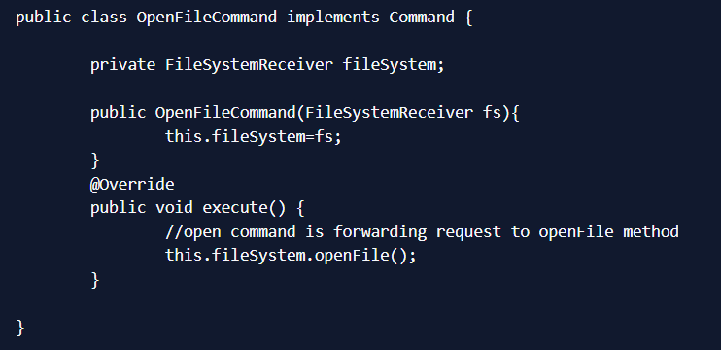
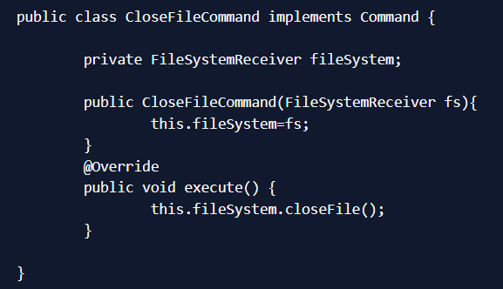
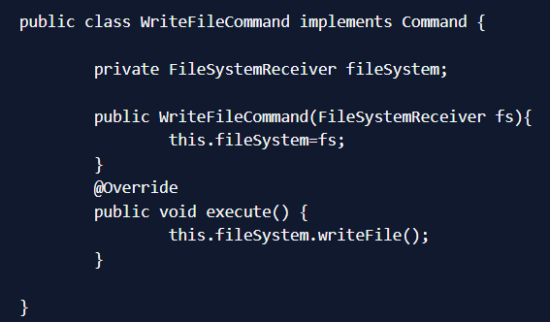
Now we have receiver and command implementations ready, so we can move to implement the invoker class.
Command Pattern Invoker Class
Invoker is a simple class that encapsulates the Command and passes the request to the command object to process it.
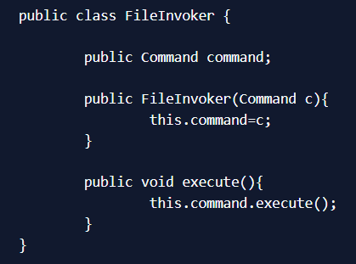
Our file system utility implementation is ready and we can move to write a simple command pattern client program. But before that I will provide a utility method to create the appropriate FileSystemReceiver object. Since we can use System class to get the operating system information, we will use this or else we can use Factory pattern to return appropriate type based on the input.
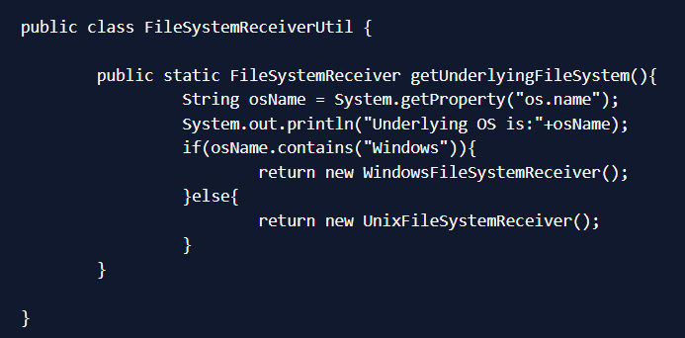
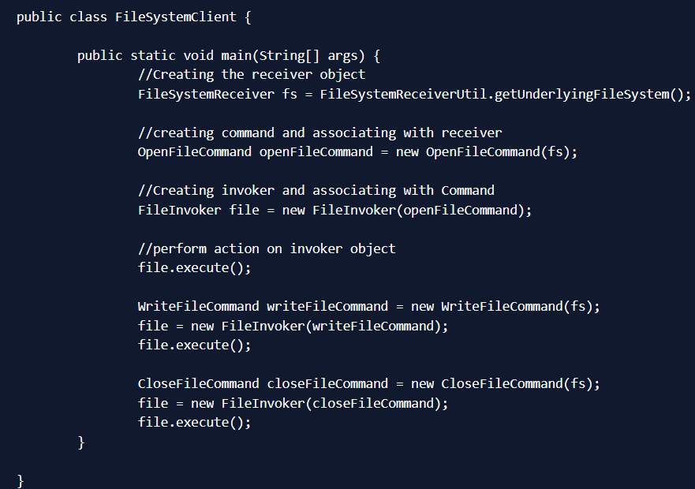
Notice that client is responsible to create the appropriate type of command object. For example if you want to write a file you are not supposed to create CloseFileCommand object. Client program is also responsible to attach receiver to the command and then command to the invoker class. Output of the above command pattern example program is:
Command Pattern Important Points
- Command is the core of command design pattern that defines the contract for implementation.
- Receiver implementation is separate from command implementation.
- Command implementation classes chose the method to invoke on receiver object, for every method in receiver there will be a command implementation. It works as a bridge between receiver and action methods.
- Invoker class just forward the request from client to the command object.
- Client is responsible to instantiate appropriate command and receiver implementation and then associate them together.
- Client is also responsible for instantiating invoker object and associating command object with it and execute the action method.
- Command design pattern is easily extendible, we can add new action methods in receivers and create new Command implementations without changing the client code.
- The drawback with Command design pattern is that the code gets huge and confusing with high number of action methods and because of so many associations.
Command Design Pattern JDK Example
Runnable interface (java.lang.Runnable) and Swing Action (javax.swing.Action) uses command pattern.
State Design Pattern:
State design pattern is used when an Object change its behavior based on its internal state.

If we have to change the behavior of an object based on its state, we can have a state variable in the Object. Then use if-else condition block to perform different actions based on the state. State design pattern is used to provide a systematic and loosely coupled way to achieve this through Context and State implementations. State Pattern Context is the class that has a State reference to one of the concrete implementations of the State. Context forwards the request to the state object for processing. Let’s understand this with a simple example. Suppose we want to implement a TV Remote with a simple button to perform action. If the State is ON, it will turn on the TV and if state is OFF, it will turn off the TV. We can implement it using if-else condition like below; TVRemoteBasic.java
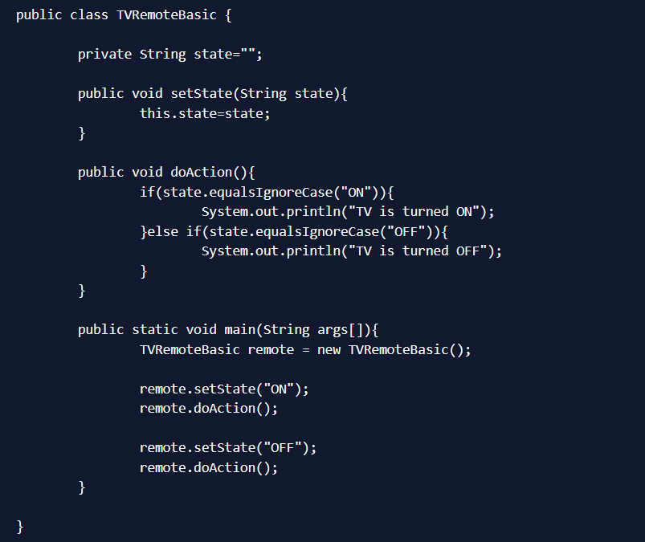
Notice that client code should know the specific values to use for setting the state of remote. Further more if number of states increase then the tight coupling between implementation and the client code will be very hard to maintain and extend. Now we will use State pattern to implement above TV Remote example.
State Design Pattern Interface
First of all we will create State interface that will define the method that should be implemented by different concrete states and context class. State.java
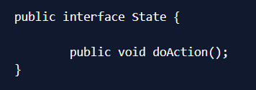
State Design Pattern Concrete State Implementations
In our example, we can have two states - one for turning TV on and another to turn it off. So we will create two concrete state implementations for these behaviors. TVStartState.java

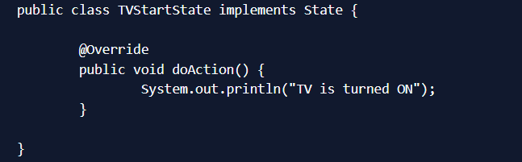
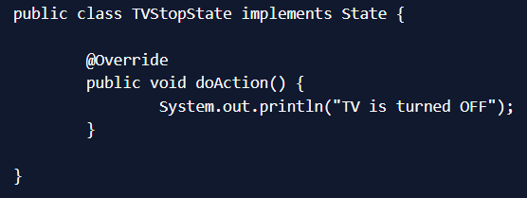
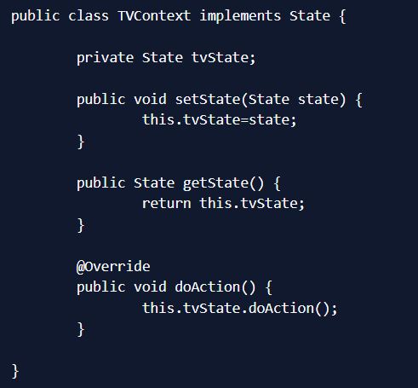
Notice that Context also implements State and keep a reference of its current state and forwards the request to the state implementation.
State Design Pattern Test Program
Now let’s write a simple program to test our state pattern implementation of TV Remote. TVRemote.java
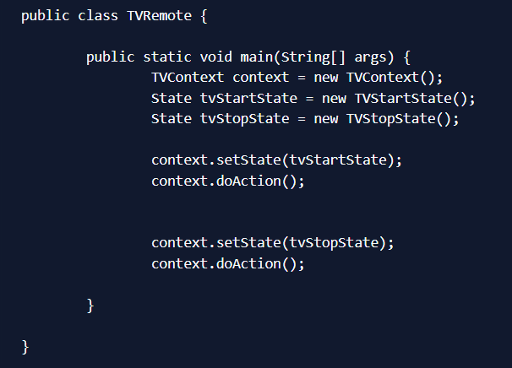
State Design Pattern Benefits
The benefits of using State pattern to implement polymorphic behavior is clearly visible. The chances of error are less and it’s very easy to add more states for additional behavior. Thus making our code more robust, easily maintainable and flexible. Also State pattern helped in avoiding if-else or switch-case conditional logic in this scenario. State Pattern is very similar to Strategy Pattern, check out Strategy Pattern in Java.

